There are 5817 points in the highest bar.

There seems to be a concentration of accidents near the big cities like London, Birmingham, etc.

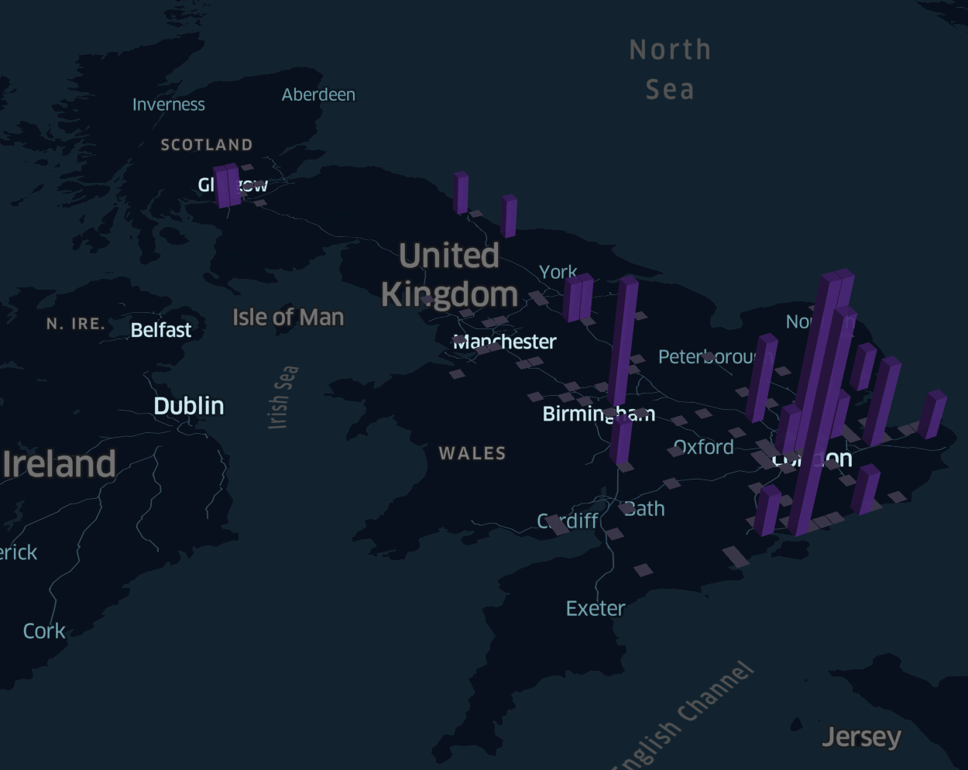

Fine with high winds.

There appear to be a similar amount of accidents in the big cities. However, it looks like there are slightly more accidents in less-populated areas when there are high winds.

It looks like there were more accidents overall in 2017 compared to 2016, as well as a higher concentration of accidents in the bigger cities like London.

It is harder to tell the difference as the radius increases. Some differences are apparent, but overall, the smaller spatial resolution that results from the increased radius means that there is less information overall being conveyed.